**Library services:**

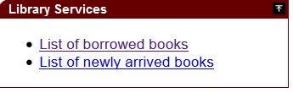

**List of borrowed books:**

Shows list of user borrowed books.

* Book Title
* Book Out Date
* Book Return Date
* Overdue

**Newly arrived books:**

Shows list of newly arrived book. By default is shows the current date. The user can see the list that arrived before by selecting customize and then select the from the options dates.

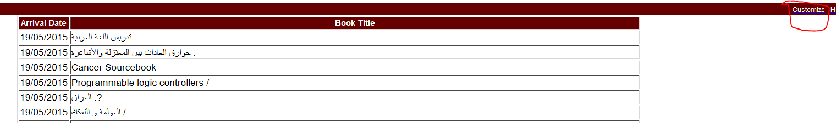

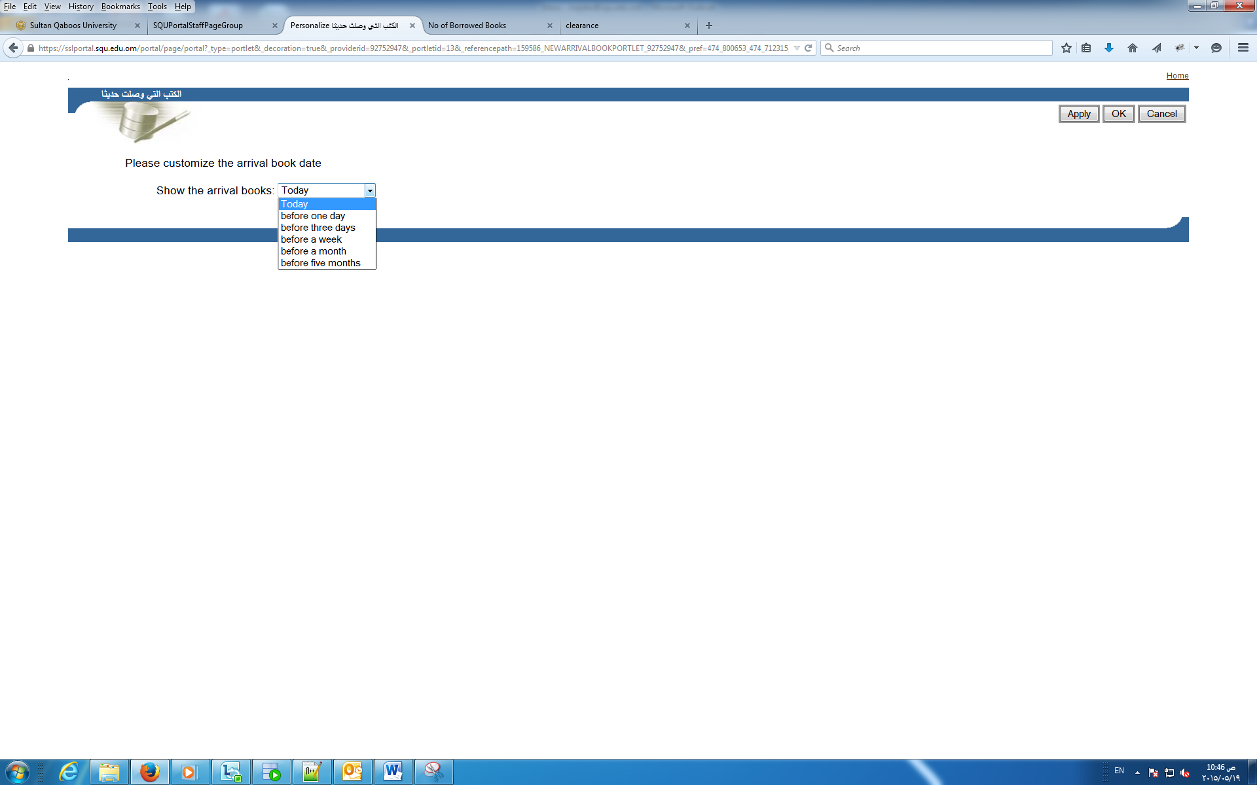

Show the arrival books:

* Today
* before one day
* before three days
* before a week
* before a month
* before five months
* Number of overdue days